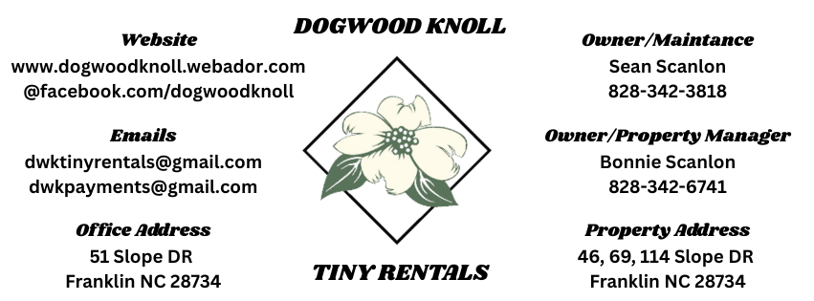

**Short Term Lease**

Tenant name: __________________________________

Owner/Landlord name: Sean Scanlon & Bonnie Scanlon

Property Address: Slope Dr (Unit)46A 69A 69B 114A 114B 114C 114D

City FRANKLIN State NC Zip 28734

* **Term of The Rental Agreement**

This agreement shall begin on ___________ and end on _____________. At the end of the lease term normal wear and tear is expected, however tenant agrees to turn property over in a peaceful manner and in good working order.

Proper notice requires Tenant to give at least ___10 days notice before ending date or before the end of any renewal term. If no notice is given, then the agreement will automatically renew on a continual month to month basis.

**Initial: ________ DWK TINY RENTALS PAGE 1 of 7**

* **Deposit for Monthly Rental Agreement**

Security Deposit, in the amount of $ (Cash/Check/ Credit) will be held as security against damages. This is Refundable. Your Security Deposit of $_______ is required to hold a unit. This is non-refundable if you are a no show at check in. If contract is broken early, the security deposit becomes non-refundable.

* **DAMAGES**

In general, most guests are very respectful of the property. However, there is always that one bad apple that causes us to have to enforce the following policies.

**\*\*\*** If there is a need for any excessive cleaning upon your departure, your card on file will be charged depending on the nature of the mess and/or damage.

**\*\*\*** Any theft or vandalism will be photographed and reported to the police and possibly followed by litigation.

**\*\*\*** Any Unit that is left unsecured by the guest, resulting in items being damaged or stolen, will be the Responsibility of the registered guest. He/she will incur the cost of replacing any items which are damaged or stolen.

**\*\*\*** Any guest that we are forced to evict will forfeit all monies paid and no credits will be issued.

Tenant will return all keys and give Landlord written notice of Tenant’s new mailing address for the return of Security Deposit. Within 10 days after Tenant moves from the Property, Refunds also by Venmo and other payment services. Landlord will give Tenant a written list of any damage to the Property for which the Landlord claims Tenant is responsible. Landlord may deduct repair costs and any unpaid Rent from Tenant’s Security Deposit. BY SIGNING, INITIALING AND PROVIDING YOUR CREDIT CARD INFORMATION FOR THIS RENTAL AGREEMENT, YOU ARE AGREEING THAT YOU WILL ABIDE BY THE POLICIES AND PROCEDURES STATED IN THIS AGREEMENT.

**Initial: ________ DWK TINY RENTALS PAGE 2 of 7**

* **Total Move in Money Required**

First month rent of $________ and security deposit of $________

And pet deposit of $_________ Total amount due at move in: $________

* **Amount of Monthle Rent**

Rent is due in advance, without demand, on or before the following month. The amount of Total Rent due during the Term is: $ ___________ Rental payment cash or check, can be left on counter in unit, dropped off to Landlords. Sent by Venmo (Sean Scanlon or Bonnie Scanlon) Add $5.00 for service fee.

* **Late Fees & Returned Payment Fees**

Tenant will pay a late fee of $3.00 per day if rent is paid on their due by date. If a payment is returned by a financial institution for any reason, there will be a charge of $ 35.00

* **Number of Occupants Allowed**

Only persons listed on this rental agreement may reside in the rented premises unless agreed to in writing by the landlord. Some units can house 2 people. Extra Person Fee Applies. Visiting Family Members Need To Be Approved.

List designated occupants here NO ONE UNDER THE AGE OF 13 unless for an approved visit.

**Initial: ________ DWK TINY RENTALS PAGE 3 of 7**

* **Pets**

Tenant shall not keep domestic or any animals without prior written consent from landlord. Landlord may allow for pets if the tenant pays a non-refundable pet deposit of $________ No **Dogs Over 15 Pounds.** Pets MUST have regular Flea & Tick treatments. Lease is responsible for all damages. Please be respectful and clean up after walks.

* **SMOKING**

NO SMOKING/VAPING INSIDE UNITS. NO USE OF CANDLES OR PLUG INS. If there is any evidence of smoking inside the Units an additional charge of $150 cleaning fee will be placed on your credit card. Please enjoy your smokes, vapes and other products outside. Thank you

* **LINENS**

You may use your own linens or we can provide Bedding & Towels. **Please feel free to wash. No harsh chemicals on towels please.**

* **PERSONAL ITEMS**

Personal items left behind or lost during a stay are the responsibility of the guest. We are not responsible for items left behind or lost.

**Initial: ________ DWK TINY RENTALS PAGE 4 of 7**

**UNOCCUPIED UNITS**

If you are not using the unit . **SET** Air 74/Heat 66 **degrees**. PLEASE **NO** Food left out and Counters wiped down, dirty dishes washed.. Turn off lights. Trash placed outside in trash can. Keep Deck clean. If this becomes an issue a Abuse of Amenities Fee of $10 a day while apply

* **WHEN DEPARTING**

Guests are required to leave the property in the same general condition it was when the guest(s) arrived. In order to help to keep the Unit cozy for the next renter, please adhere to the following rules upon departure:

** All dishes must be washed and put away. Dish soap, kitchen towels, etc. are provided in each Unit.

** Refrigerator should be left clean, free of all food, beverages and contents.

** Bag all trash and place it in the trashcans provided.

** Place wet towels, washcloths hanging over shower please,

** Turn off all lights and small appliances and set the air unit to 70 degrees and on Auto Setting.

**Be sure **all the doors and windows are locked**.

*** The Units are not to be used for parties or gatherings. Full payment for all damages, missing items and extra cleaning are the responsibility of the guest and **will** **be billed to the credit card of the guest who signs the rental agreement.**

USES OF ILLEGAL DRUGS OR POSSESSION OF ILLEGAL FIREARMS OR FIREWORKS ARE PROHIBITED AT DOGWOOD KNOLL. IF YOU ARE FOUND TO HAVE EITHER IN YOUR POSSESION, YOU WILL BE ASKED TO LEAVE WITH NO MONEY REFUNDED.

**Initial: ________ DWK TINY RENTALS PAGE 5 of 7**

* **SIGNED CONTRACT**

Please remember that a signed rental agreement is considered a legal and binding contract and therefore gives DOGWOOD KNOLL the right to collect payment for damages, missing items, and excessive cleaning that are made necessary by your stay.

**\*\*\* Failure to breach any part of signed contract will result in Evection\*\*\***

* **INDEMNITY CLAUSE**

The registered renter agrees to indemnify DOGWOOD KNOLL of any damages to the premises which result from the renter's occupancy (including furnishings and household items) and/or damages found upon arrival. The registered guest is the one who will be charged for any damages his/her group causes to the property. DOGWOOD KNOLL will not be held responsible for accidents or injury to guests or for loss of money or valuables of any kind. The registered guest assumes full responsibility for any and all damages that his/her group causes, excessive cleaning charges for problems caused by his/her group, or for any items found to be missing after his/her group's visit, including linens and towels. By accepting this reservation, it is agreed that all guests of the registered renter are expressly assuming the risk of any harm arising from their use of the premises or others whom they invite to use the premises.

**Initial: ________ DWK TINY RENTALS PAGE 6 of 7**

IN WITNESS THEREOF, the Parties have caused this Lease to be executed on the day and year first above written.

**LANDLORD**

[____________________________________________](https://esign.com/)

Signature Date

Name (print) _________________________________

**TENANT(S)**

[__________________________________________________________](https://esign.com/)

Signature Date

Name (print) ________________________________________________

State of North Carolina

County of Macon

This instrument was acknowledged before me this _____day of _____________ (month), _________ (year), by________________ (name of officer or agent, title or officer or agent) of _________________________________ (name of corporation acknowledging) a ___________ (state or place of incorporation) corporation, on behalf of the corporation.

_____ Personally Known

_____ Produced Identification

Type and # of ID_____________________________

(Seal) ________________________ (Signature Notary)

**PAGE 7 of 7**